H1B VISA APPLICANTS CASE STUDY USING HADOOP FRAMEWORK

**PRESENTED BY**

**RIA SADHU**

**BATCH ID –S170026**

H1b is an employment based, immigrant visa category for temporary foreign national in US

**1.ABSTRACT**

The project is focussed on analysis of H1B VISA APPLICATIONS. Using Hadoop, an open source framework for distributed computing, the raw data of the h1b visa is processed and analysed.

For applying h1b visa, employer in US has to offer a job along with h1b visa petition with the US immigration department.

The dataset has nearly 3 million records.

The dataset description is as follows:

The columns in the dataset include:

2. **CASE_STATUS**: Status associated with the last significant event or decision. Valid values include “Certified,” “Certified-Withdrawn,” Denied,” and “Withdrawn”.

Certified: Employer filed the LCA, which was approved by DOL

Certified Withdrawn: LCA was approved but later withdrawn by employer

Withdrawn: LCA was withdrawn by employer before approval

Denied: LCA was denied by DOL

3. **EMPLOYER_NAME**: Name of employer submitting labour condition application.

4. SOC_NAME: the Occupational name associated with the SOC_CODE. SOC_CODE is the occupational code associated with the job being requested for temporary labour condition, as classified by the Standard Occupational Classification (SOC) System.

5. **JOB_TITLE**: Title of the job

6. **FULL_TIME_POSITION**: Y = Full Time Position; N = Part Time Position

7. **PREVAILING_WAGE:** Prevailing Wage for the job being requested for temporary labour condition. The wage is listed at annual scale in USD. The prevailing wage for a job position is defined as the average wage paid to similarly employed workers in the requested occupation in the area of intended employment. The prevailing wage is based on the employer’s minimum requirements for the position.

8. **YEAR**: Year in which the H1B visa petition was filed

9. **WORKSITE**: City and State information of the foreign worker’s intended area of employment

10. **lon**: longitude of the Worksite

11. **lat**: latitude of the Worksite

**2.BIG DATA:**

Due to the advent of new technologies, devices, and communication means like social networking sites, applications the amount of data produced by mankind is growing rapidly every year.

Its not easy to measure the total volume of data stored electronically.

This flood of data coming from many Sources

• Facebook hosts more than 240 billion photos , growing at 7 PB per months

• The New York Stock Exchange generates 4-5 PB per day

• And there are lot of data - 4.4 ZB of data collected in 2003 and forecasting 44 ZB in 2020

**Thus, Big Data includes 4Vs:**

• Huge volume of data : Rather than thousands or million of rows/records , Big data can be billions of rows and millions of columns

• Variety – Data can be any form ,structure

• Velocity – Big data can be describe as high velocity data i.e speed of new data creation is rapid ,high data ingestion and near real time analysis

• Veracity - The quality of the data being captured can vary greatly. Accuracy of analysis depends on the veracity of the source data

**The data in it will be of three types:**

**Structured data**: Relational data.

**Semi Structured data**: XML data.

**Quasi-structured**: A somewhat inconsistent (for example, a hyperlink)

**Unstructured data**: Word, PDF, Text, Media Logs.

**2.1 Types of Data Structure available:**

• Structured: A specific and consistent format

(for example, a data table)

• Semi-structured : A self-describing format(for example XML file)

• Quasi-structured: A somewhat inconsistent (for example, a hyperlink)

• Unstructured : An inconsistent format(for example , text or video)

**2.2Main Problem:**

THE PROBLEM HERE IS HOW TO ANALYSE AND STORE HUGE VOLUME OF DATA

• How to store & analyse such huge data?

• Problem :Lots of data of varied form

Need to process 100TB datasets On 1 node: – reading@ 100MB/s = 277.7 hrs. = 11 days

Suppose we have 1000 nodes then the same

Data can be read =16.2 minutes only if nodes working in parallel.

**3.HADOOP:**

Hadoop is an Apache open source framework written in java that allows distributed processing of large datasets across clusters of computers using simple programming models.

Hadoop is designed to scale up from single server to thousands of machines, each offering local computation and storage.

**3.1 HISTORY OF HADOOP:**

The genesis of Hadoop was the "Google File System" paper that was published in October 2003.[12] This paper spawned another one from Google – "MapReduce: Simplified Data Processing on Large Clusters".[13] Development started on the Apache Nutch project, but was moved to the new Hadoop subproject in January 2006.[14] Doug Cutting, who was working at Yahoo! at the time,[15] named it after his son's toy elephant.[16] The initial code that was factored out of Nutch consisted of about 5,000 lines of code for HDFS and about 6,000 lines of code for MapReduce.

3.2) MODULES IN HADOOP:

The project uses these modules:

* Hadoop Common – contains libraries and utilities needed by other Hadoop modules;

* Hadoop Distributed File System (HDFS) – a distributed file-system that stores data on commodity machines, providing very high aggregate bandwidth across the cluster;

* Hadoop YARN – a platform responsible for managing computing resources in clusters and using them for scheduling users' applications;[6][7] and

* Hadoop MapReduce – an implementation of the MapReduce programming model for large-scale data processing

* Pig- consists of high level scripting language Pig Latin ,used for extract ,transform ,load(ETL) data pipelines

* Hive- is a SQL based data warehouse system for data summarization, ad-hoc query, and analysis of large datasets

**4.HDFS (HADOOP DISTRIBUTED FILE SYSTEM):**

Hadoop File System was developed using distributed file system design. It runs on commodity hardware. Unlike other distributed systems, HDFS is highly fault tolerant and designed using low-cost hardware.

HDFS holds very large amount of data and provides easier access. To store such huge data, the files are stored across multiple machines. These files are stored in redundant fashion to rescue the system from possible data losses in case of failure. HDFS also makes applications available to parallel processing.

.

**4.1) Features of HDFS**

* Distributed Storage – Data is stored in distributed manner

* Blocks – Data is split into blocks

* Replication – Blocks are replicated at different nodes

* High Availability – Data is highly available due to replication

* Data Reliability – Data is stored reliably in HDFS

* Fault tolerant – Data replication provides fault tolerance feature

* Scalability – Nodes in HDFS cluster can be increased on the fly

* High throughput access to application – Parallel processing provides high throughput access to application

**4.2) HDFS ARCHITECTURE:**

• Single Namenode which stores the metadata of the filesystem

• Multiple Datanodes which do the actual storage work

• Nodes are Arranged in racks and replicas of each block are stored in different racks such that in case of rack failure, we can still continue with processing since replicas are present in other racks.

**4.3)HDFS CLUSTER COMPONENTS:**

**HDFS Daemons**

There are 2 daemons which run for HDFS for storage of data.

* **Namenode**: This is the daemon that runs on all the masters. Name node stores metadata like filename, the number of blocks, number of replicas, a location of blocks, block IDs etc. This metadata is available in memory in the master for faster retrieval of data. In the local disk, a copy of metadata is available for persistence. So name node memory should be high as per the requirement. It should be deployed on reliable hardware.

* **Datanode**: This is the daemon that runs on the slave. These are actual worker nodes that store the data. These slave nodes are the actual worker nodes which do the tasks and serve read and write requests from the file system’s clients. They also perform block creation, deletion, and replication upon instruction from the NameNode. Once a block is written on a datanode, it replicates it to other datanode and process continues until the number of replicas mentioned is created. Datanodes can be deployed on commodity Hardware and we need not deploy them on very reliable hardware.

**BLOCK**: HDFS splits huge files into small chunks known as blocks. Block is the smallest unit of data in a filesystem. We (client and admin) do not have any control on the block like block location. Namenode decides all such things.HDFS default block size is 128 MB which can be increased as per the requirement. This is unlike OS filesystem where the block size is 4 KB.If the data size is less than the block size, then block size will be equal to the data size. For example, if the file size is 129 MB, then 2 blocks will be created for it. One block will be of default size 128 MB and other will be 1 MB only and not 128 MB as it will waste the space (here block size is equal to data size). Hadoop is intelligent enough not to waste rest of 127 MB. So it is allocating 1 MB block only for 1 MB data.The major advantage of storing data in such block size is that it saves disk seek time and another advantage is in the case of processing as mapper processes 1 block at a time. So 1 mapper processes large data at a time.The file is split into blocks and each block is stored at different nodes with default 3 replicas of each block. Each replica of a block is stored at the different node to provide fault tolerant feature and the placement of these blocks on the different node is decided by Name node.

**5.PROJECT IMPLEMENTATION:**

**5.1) Assumptions:**

• Hadoop Cluster is Running

• Ecosystem Products (Pig, Hive) are installed

• Census data is available on HDFS in CSV Format

**5.2) Prerequisites:**

The Census data is in csv format in hadoop file system. But we need to remove white spaces,” ” and other punctuations in the file and also we need to trim 3 case –status i.e

PENDING QUALITY AND COMPLIANCE REVIEW, REJECTED, INVALIDATED to DENIED

For that we use HIVE.

**6. HIVE:**

Apache Hive is a SQL Based data warehouse systembuilt on top of Hadoop for providing data summarization, query, and analysis. Hive gives an SQL-like interface to query data stored in various databases and file systems that integrate with Hadoop.

**6.1) Steps for Conversion**: Created 3 tables in hive shown below

Task 1) CREATE TABLE h1b_applications(s_no int,case_status string,

employer_name string, soc_name string, job_title string,

full_time_position string,prevailing_wage int,year string, worksite

string, longitute double, latitute double )

ROW FORMAT SERDE 'org.apache.hadoop.hive.serde2.OpenCSVSerde'

WITH SERDEPROPERTIES (

"separatorChar" = ",",

"quoteChar" = "\""

) STORED AS TEXTFILE;

load data local inpath '/home/hduser/h1b.csv' overwrite into table

h1b_applications;

Task2) CREATE TABLE h1b_app2(s_no int,case_status string, employer_name

string, soc_name string, job_title string, full_time_position

string,prevailing_wage int,year string, worksite string, longitute

double, latitute double )

row format delimited

fields terminated by '\t'

STORED AS TEXTFILE;

INSERT OVERWRITE TABLE h1b_app2 SELECT regexp_replace(s_no, "\t", ""),

regexp_replace(case_status, "\t", ""), regexp_replace(employer_name,

"\t", ""), regexp_replace(soc_name, "\t", ""),

regexp_replace(job_title, "\t", ""),

regexp_replace(full_time_position, "\t", ""),

regexp_replace(prevailing_wage, "\t", ""), regexp_replace(year, "\t",

""), regexp_replace(worksite, "\t", ""), regexp_replace(longitute,

"\t", ""), regexp_replace(latitute, "\t", "") FROM h1b_applications

where case_status != "NA";

Task3)CREATE TABLE h1b_final(s_no int,case_status string, employer_name

string, soc_name string, job_title string, full_time_position

string,prevailing_wage int,year string, worksite string, longitute

double, latitute double )

row format delimited

fields terminated by '\t'

STORED AS TEXTFILE;

INSERT OVERWRITE TABLE h1b_final SELECT s_no,

case when trim(case_status) = "PENDING QUALITY AND COMPLIANCE REVIEW - UNASSIGNED" then "DENIED"

when trim(case_status) = "REJECTED" then "DENIED"

when trim(case_status) = "INVALIDATED" then "DENIED"

else case_status end,

employer_name, soc_name, job_title,

full_time_position,prevailing_wage,year, worksite, longitute, latitute

FROM h1b_app2;

**TASK 1:**

**Task 1.) Which industry(SOC_NAME) has the most number of Data Scientist positions?**

select soc_name ,count(soc_name) as soc_count from h1b_final where job_title like'%DATA SCIENTIST%' group by soc_name order by soc_count desc limit 1;

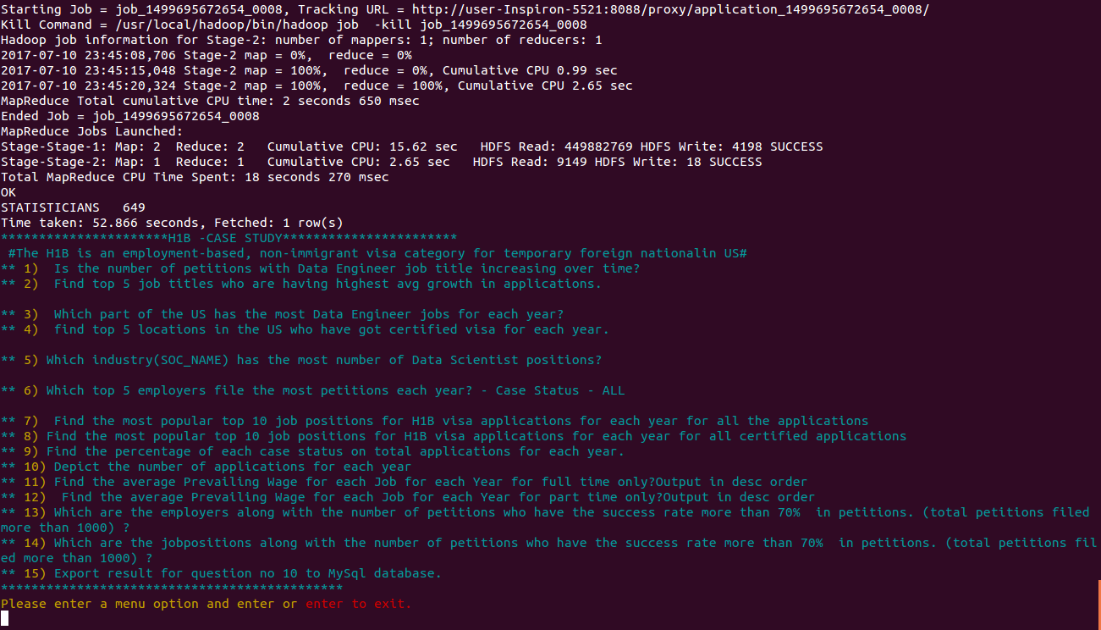**Task2)**

**5) Find the most popular top 10 job positions for H1B visa applications for each year?**

**a) for all the applications**

**b) for only certified applications.**

create table 5year11(year int,job_title string)row format delimited fields terminated by '\t' stored as textfile;

insert overwrite table y21 select year,job_title from h1b_final;

5 a)select job_title,year,count(job_title) as count from h1bapplication.5year11 where year=2011 group by job_title,year order by count desc limit 10;

select job_title,year,count(job_title) as count from h1bapplication.5year11 where year=2012 group by job_title,year order by count desc limit 10;

select job_title,year,count(job_title) as count from h1bapplication.5year11 where year=2013 group by job_title,year order by count desc limit 10;

select job_title,year,count(job_title) as count from h1bapplication.5year11 where year=2014 group by job_title,year order by count desc limit 10;

select job_title,year,count(job_title) as count from h1bapplication.5year11 where year=2015 group by job_title,year order by count desc limit 10;

select job_title,year,count(job_title) as count from h1bapplication.5year11 where year=2016 group by job_title,year order by count desc limit 10;

for 2011



For 2012

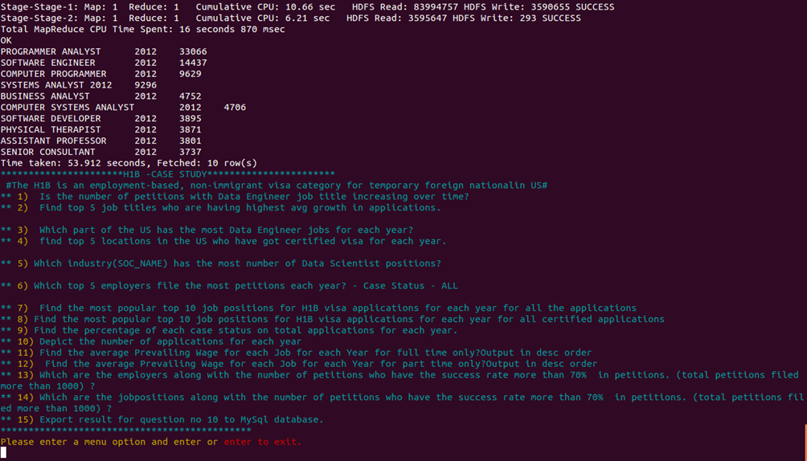

For 2013

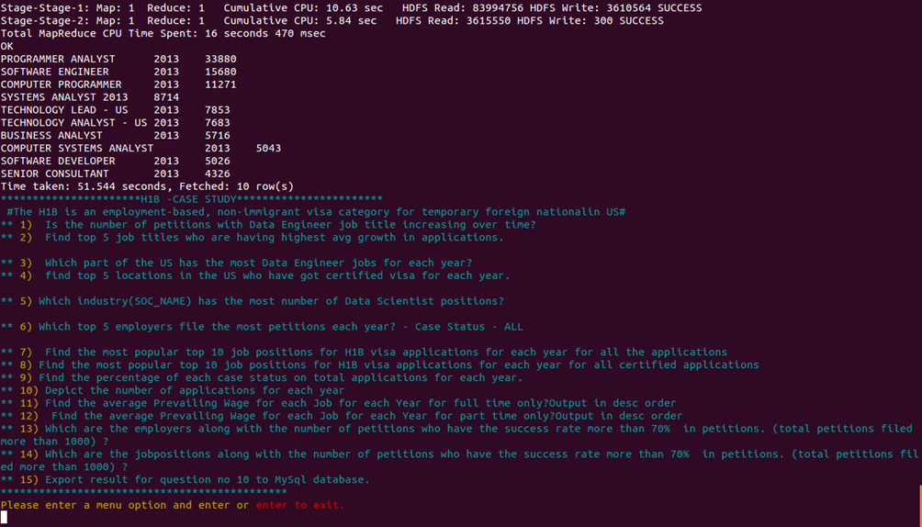

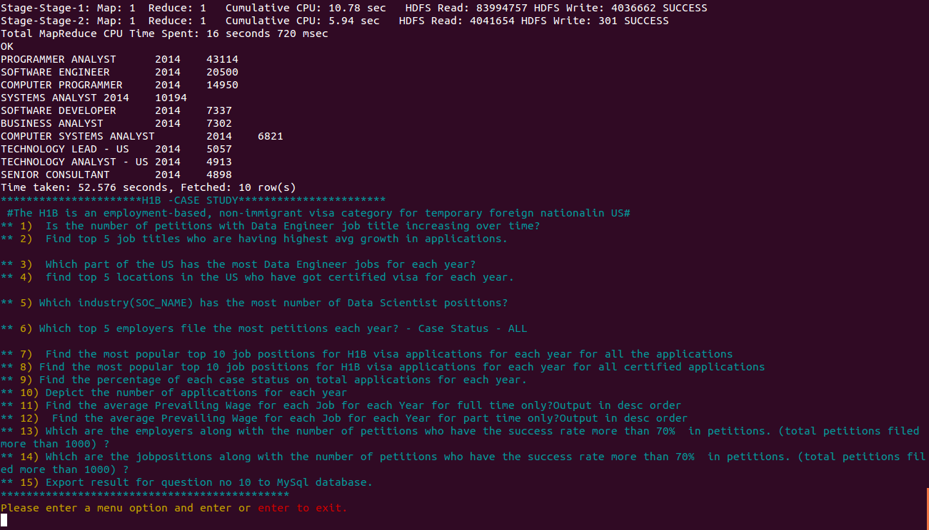For 2014

For 2015

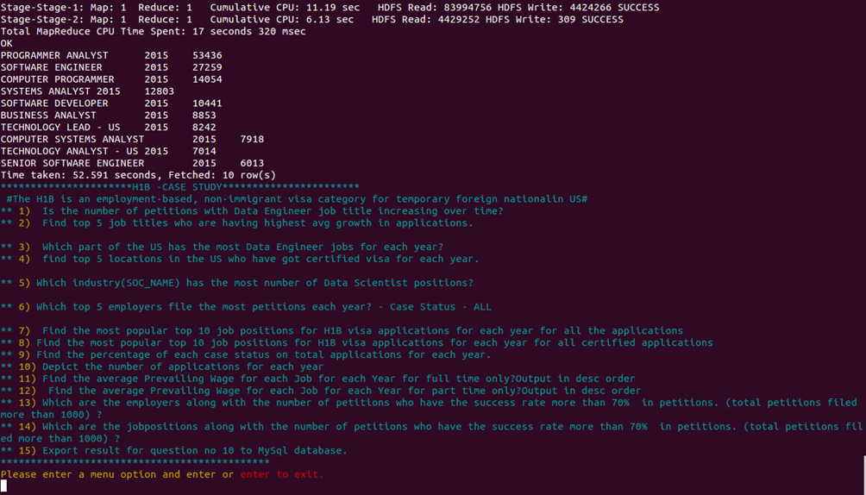

For 2016

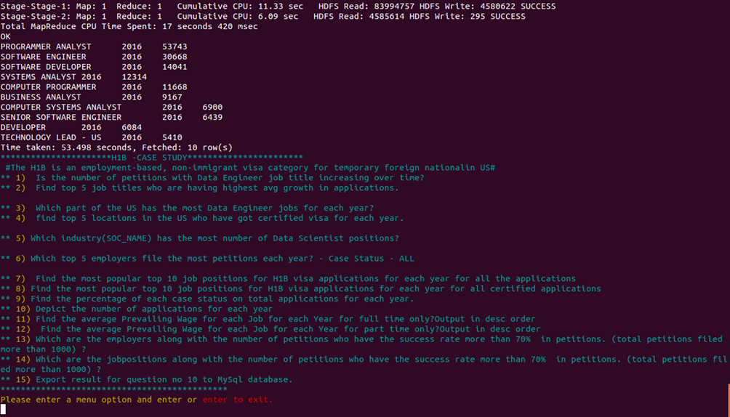

5b)

create table 5byear11(year int,jobtile string,case_status string) row format delimited fields terminated by '\t' stored as textfile;

insert overwrite table 5byear11 select year,job_title,case_status from h1b_final;

5 b)select jobtile,year,count(jobtile),case_status as count from h1bapplication.5byear11 where year=2011 and case_status =='CERTIFIED' group by jobtile,year,case_status order by count desc limit 10;

select jobtile,year,count(jobtile),case_status as count from h1bapplication.5byear11 where year=2012 and case_status =='CERTIFIED' group by jobtile,year,case_status order by count desc limit 10;

select jobtile,year,count(jobtile),case_status as count from h1bapplication.5byear11 where year=2013 and case_status =='CERTIFIED' group by jobtile,year,case_status order by count desc limit 10;

select jobtile,year,count(jobtile),case_status as count from h1bapplication.5byear11 where year=2014 and case_status =='CERTIFIED' group by jobtile,year,case_status order by count desc limit 10;

select jobtile,year,count(jobtile),case_status as count from h1bapplication.5byear11 where year=2015 and case_status =='CERTIFIED' group by jobtile,year,case_status order by count desc limit 10;

select jobtile,year,count(jobtile),case_status as count from h1bapplication.5byear11 where year=2016 and case_status =='CERTIFIED' group by jobtile,year,case_status order by count desc limit 10;

for 2011

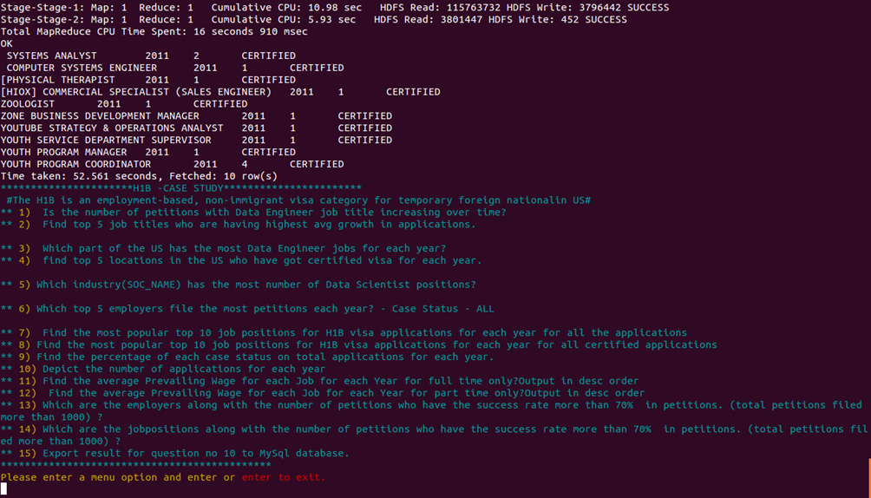

For 2012

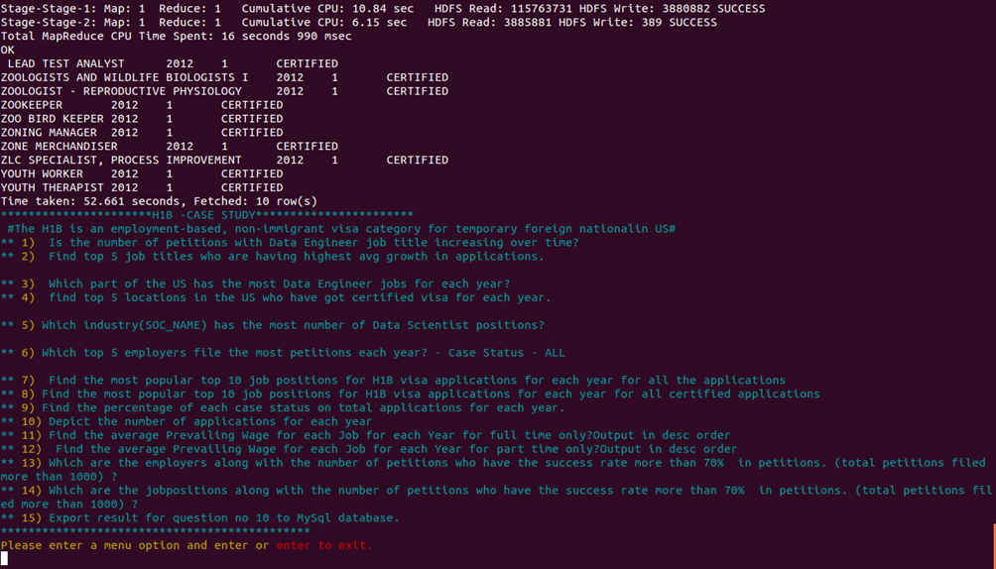

For 2013

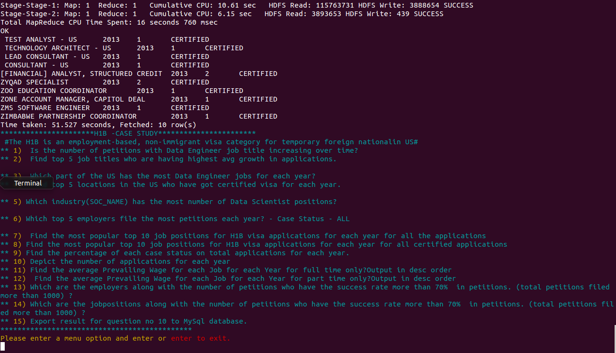

For 2014

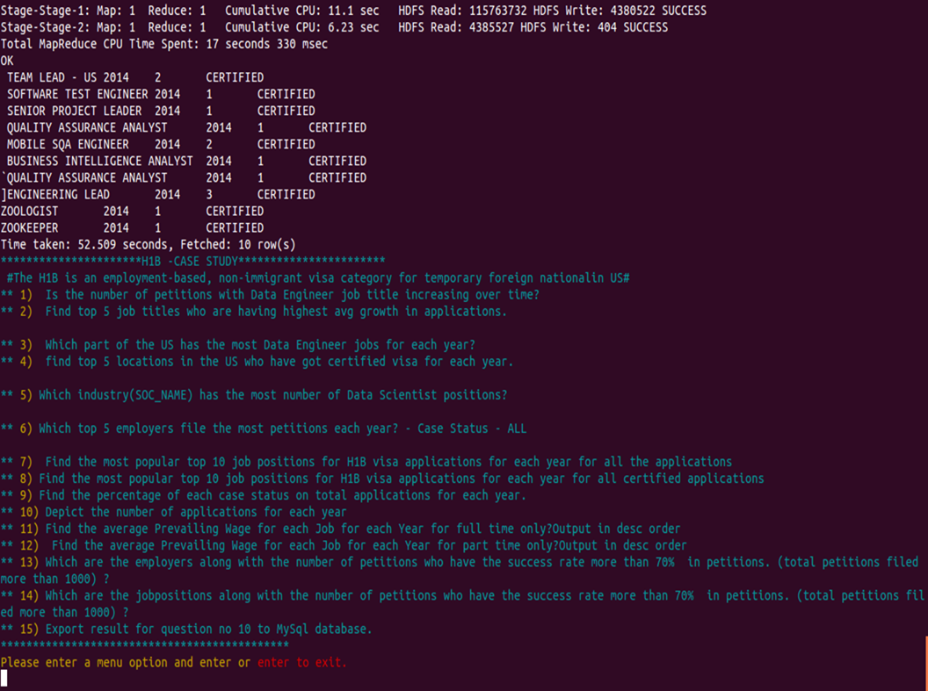

For 2015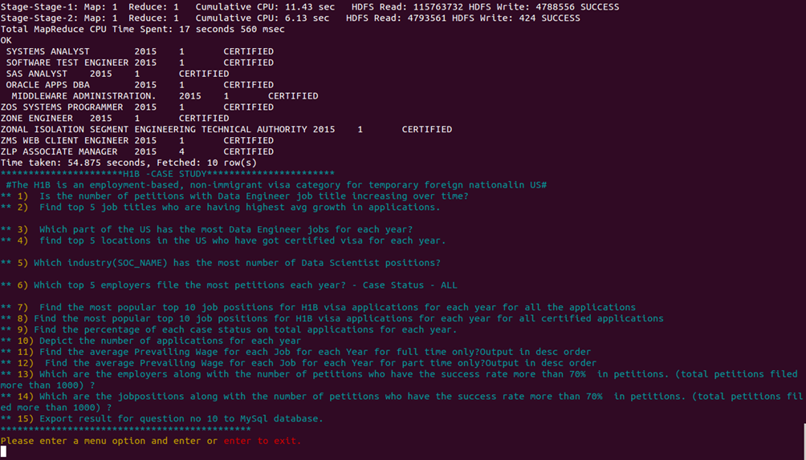

For 2016

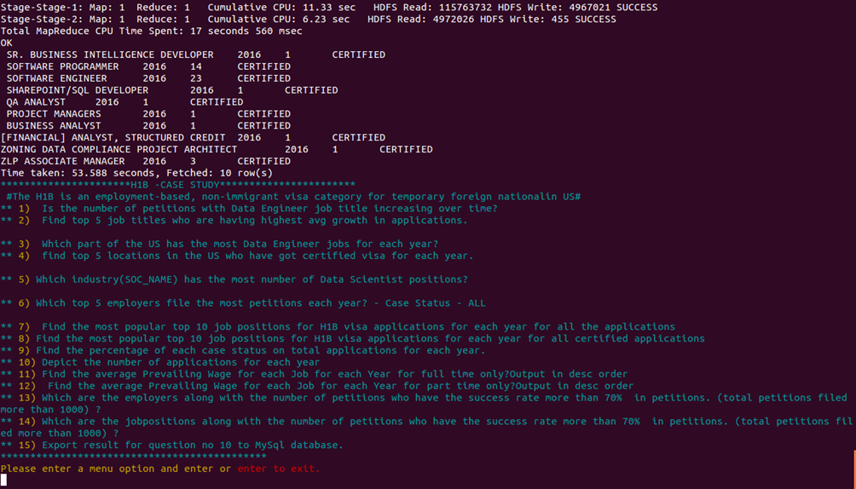

**TASK3**

**Find the average Prevailing Wage for each Job for each Year (take part time and full time separate). Arrange the output in descending order.**

create table h1b_finalByCat(s_no int,case_status string,employer_name string,soc_name string,job_title string,prevailing_wage int,year string,worksite string,longitute double,latitute double)

> partitioned by(full_time_position string)

> row format delimited fields

> terminated by'\t'

> stored as textfile;

hive (h1bapplication)> SET hive.exec.dynamic.partition = true;

hive (h1bapplication)> SET hive.exec.dynamic.partition.mode = nonstrict;

INSERT OVERWRITE TABLE h1b_finalByCat PARTITION(full_time_position)select s_no,case_status,employer_name,soc_name,job_title,prevailing_wage,year,worksite,longitute,latitute,full_time_position from h1b_final;

select year,job_title,AVG(prevailing_wage) as average from h1b_finalByCat where full_time_position ='Y'and prevailing_wage >0 group by job_title,year order by average desc;

For full time

IN FULL_TIME_POSITION ='Y' --------------------->HIGHEST AVG(PREVAILING_WAGE)------------------->2016,DIRECTOR, SOCIAL AND DIGITAL MEDIA,3.291392E8

LOWEST AVG(PREVAILING_WAGE)-------------------->2015 ADSF 52.0

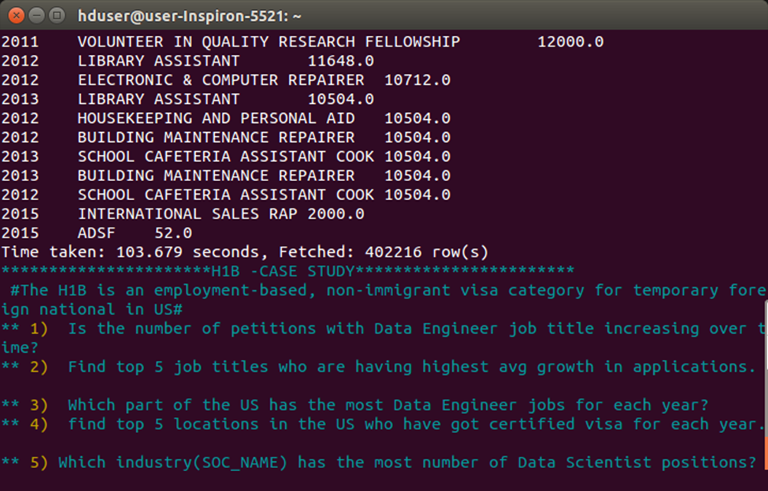

b) select year,job_title,AVG(prevailing_wage) as average from h1b_finalByCat where full_time_position ='N' and prevailing_wage >0 group by job_title,year order by average desc;

For part time

IN FUL_TIME_POSITION ='N' -------------------->HIGHEST AVG(PREVAILING_WAGE) IS 2013,MANAGEMENT ANALYST, OPERATIONS,1.2351872E8

LOWEST AVG(PREVAILING_WAGE) IS 2016 IOS AND ANDROID DEVELOPER 1278.0

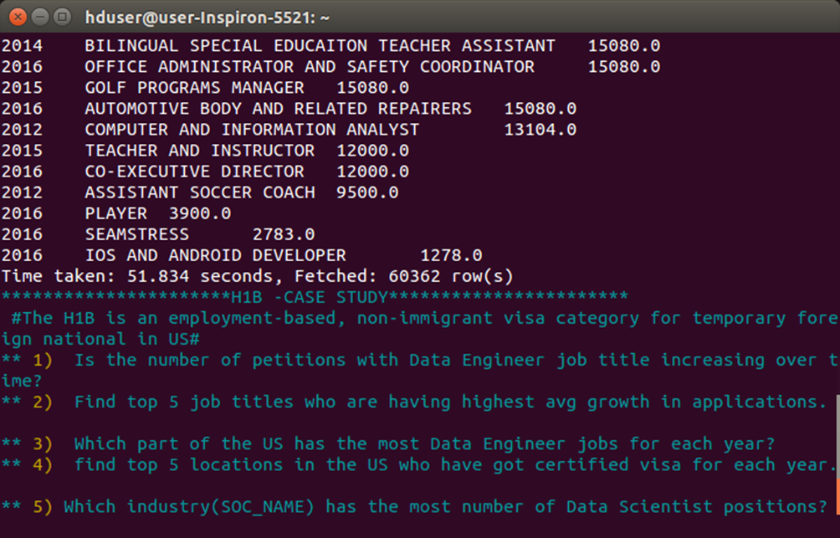

**PIG**

Apache Pig is a platform for analysing large data sets that consists of a high-level language for expressing data analysis programs, coupled with infrastructure for evaluating these programs. The salient property of Pig programs is that their structure is amenable to substantial parallelization, which in turns enables them to handle very large data sets. Pig's language layer currently consists of a textual language called Pig Latin, which has the following key properties:

* Ease of programming. It is trivial to achieve parallel execution of simple, "embarrassingly parallel" data analysis tasks. Complex tasks comprised of multiple interrelated data transformations are explicitly encoded as data flow sequences, making them easy to write, understand, and maintain.
* Optimization opportunities. The way in which tasks are encoded permits the system to optimize their execution automatically, allowing the user to focus on semantics rather than efficiency.
* Extensibility. Users can create their own functions to do special-purpose processing.

**TASK 1)**

**a) Which part of the US has the most Data Engineer jobs for each year?**

**b) find top 5 locations in the US who have got certified visa for each year**.

a)bag1 = load '/user/hive/warehouse/h1bapplication.db/h1b_final' using PigStorage() as (s_no:int,case_status:chararray,employer_name:chararray,soc_name:chararray,job_title:chararray,full_time_position:chararray,prevailing_wage:int,year:int,worksite:chararray,long:double,lati:double);

bag2 = filter bag1 by ($4 MATCHES '.*DATA ENGINEER.*');

bag3 = group bag2 by (year,worksite);

bag4 = foreach bag3 generate group,COUNT(bag2) as total;

bag5 = foreach bag4 generate FLATTEN(group),total;

bag6 = group bag5 by year;

top = foreach bag6 {

sorted = order bag5 by total desc;

top1 = limit sorted 1;

generate flatten(top1);

};

dump top;

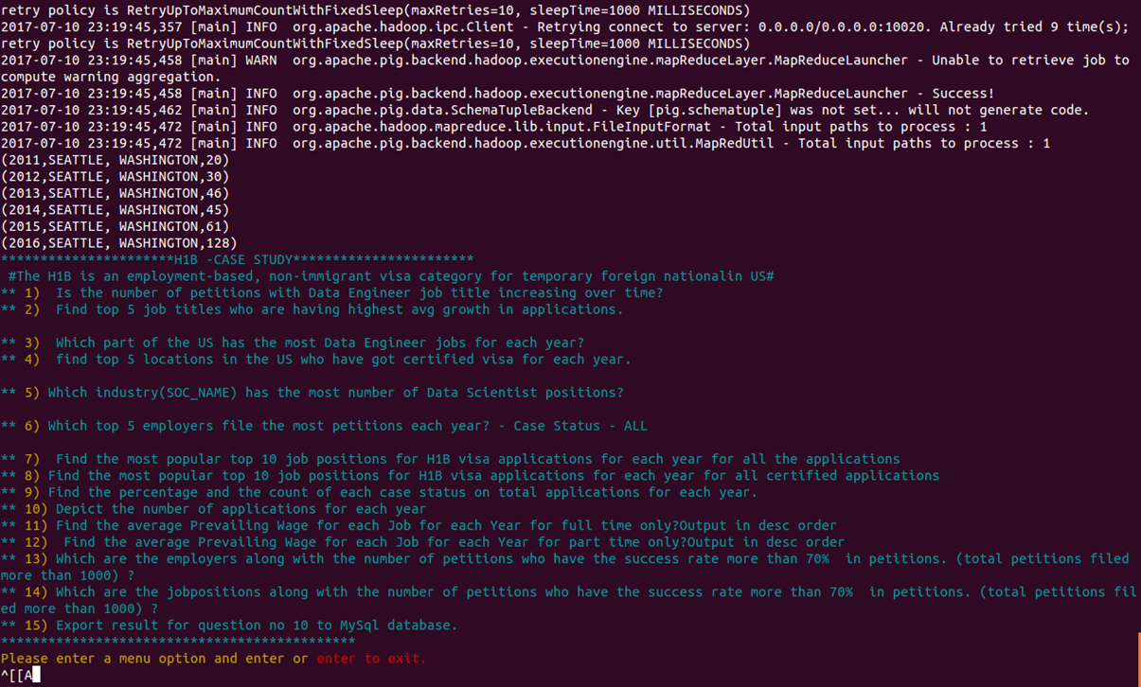

b)

bag1 = load '/user/hive/warehouse/h1bapplication.db/h1b_final' using PigStorage() as (s_no:int,case_status:chararray,employer_name:chararray,soc_name:chararray,job_title:chararray,full_time_position:chararray,prevailing_wage:int,year:int,worksite:chararray,long:double,lati:double);

bag2 = filter bag1 by ($1 MATCHES 'CERTIFIED');

bag3 = group bag2 by (year,worksite);

bag4 = foreach bag3 generate group,COUNT(bag2) as total;

bag5 = foreach bag4 generate FLATTEN(group),total;

bag6 = group bag5 by year;

bag7 = foreach bag6

{

sorted = order bag5 by total desc;

top5 = limit sorted 5;

generate FLATTEN(top5);

}

dump bag7;

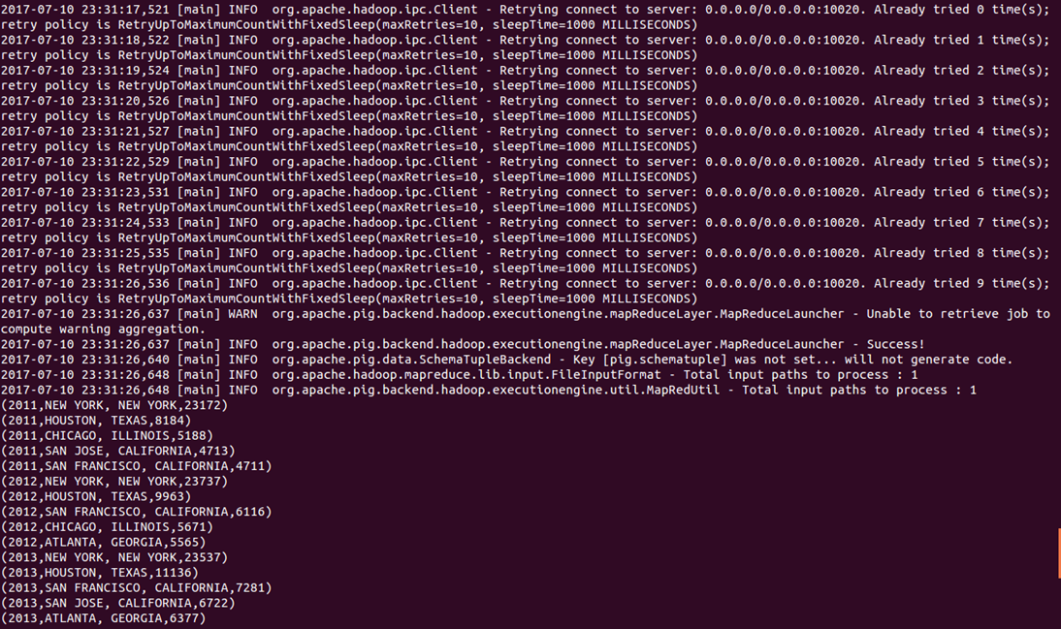

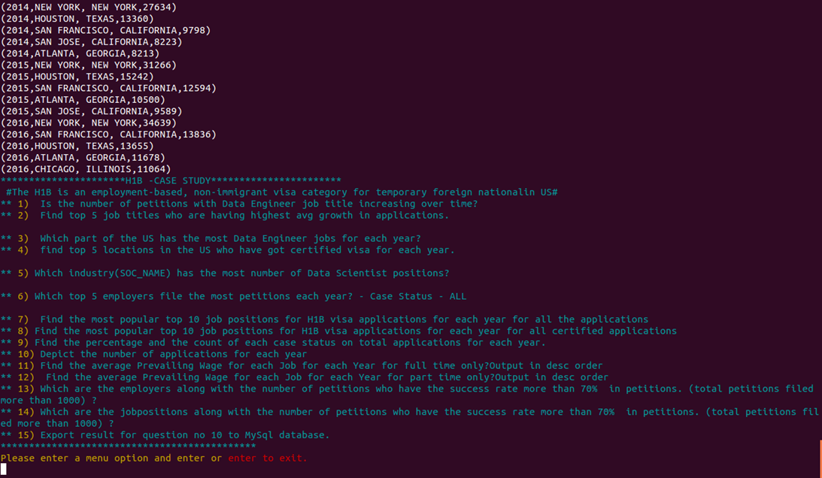

**Task2**

**Which top 5 employers file the most petitions each year? - Case Status – ALL**

bag1 = load '/user/hive/warehouse/h1bapplication.db/h1b_final' using PigStorage() as (s_no:int,case_status:chararray,employer_name:chararray,soc_name:chararray,job_title:chararray,full_time_position:chararray,prevailing_wage:int,year:int,worksite:chararray,long:double,lati:double);

bag2 = group bag1 by (employer_name,year);

bag4= foreach bag2 generate flatten(group),COUNT(bag1);

split bag4 into bag5 if year ==2011,bag6 if year ==2012,bag7 if year ==2013,bag8 if year ==2014,bag9 if year ==2015,bag10 if year ==2016;

bag11 = order bag5 by $2 desc;

bag12 = limit bag11 5;

bag13 = order bag6 by $2 desc;

bag14 = limit bag13 5;

bag15 = order bag7 by $2 desc;

bag16 = limit bag15 5;

bag17 = order bag8 by $2 desc;

bag18 = limit bag17 5;

bag19 = order bag9 by $2 desc;

bag20 = limit bag19 5;

bag21 = order bag10 by $2 desc;

bag22 = limit bag21 5;

unionism = union bag12,bag14,bag16,bag18,bag20,bag22;

dump unionism;

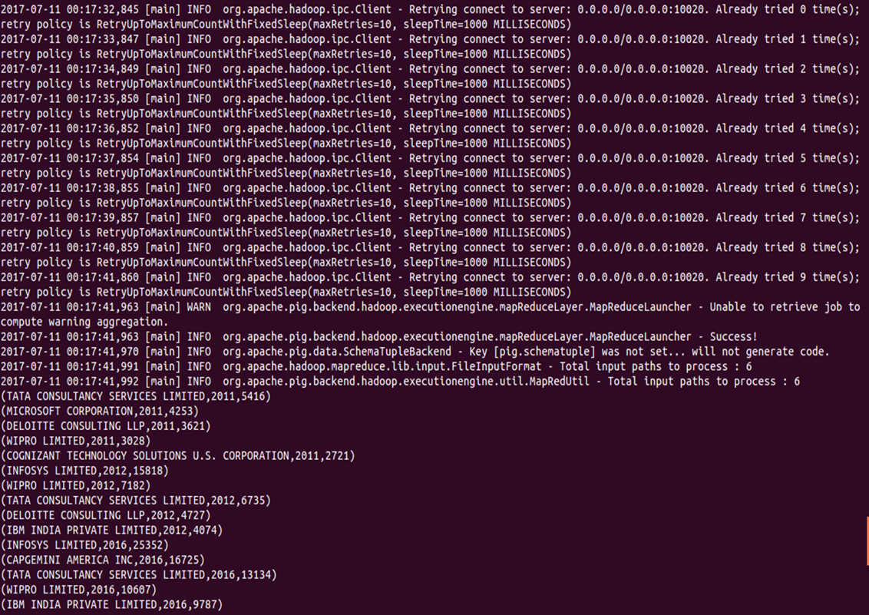



**Task3**

**Find the percentage and the count of each case status on total applications for each year. Create a line graph depicting the pattern of All the cases over the period of time**

**COUNT and PERCENTAGE**



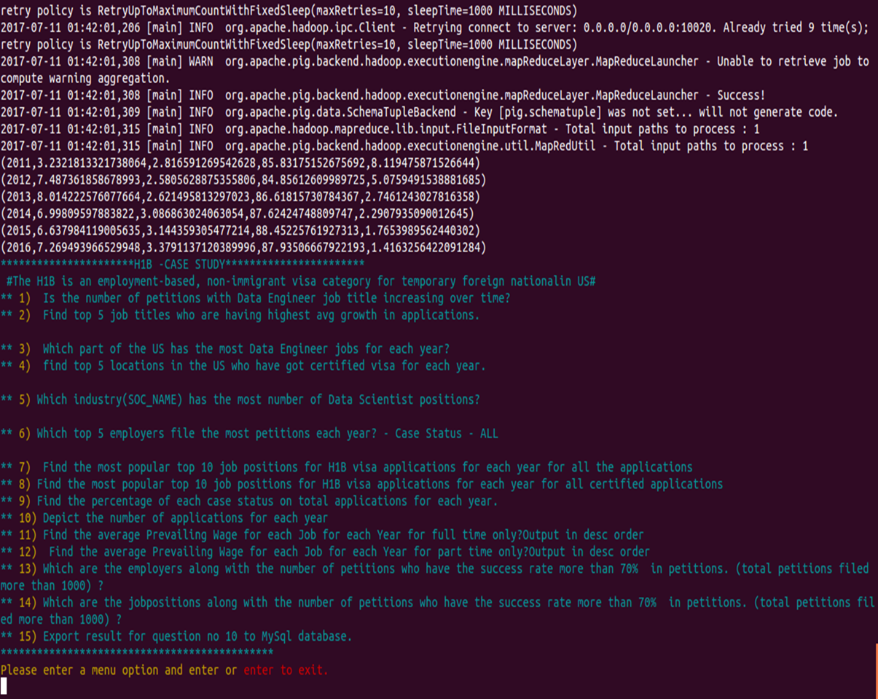

**MAPREDUCE**

MapReduce is a programming model suitable for processing of huge data. Hadoop is capable of running MapReduce programs written in various languages: Java, Ruby, Python, and C++. MapReduce programs are parallel in nature, thus are very useful for performing large-scale data analysis using multiple machines in the cluster.

**MapReduce programs work in two phases:**

1. Map phase
2. Reduce phase.

Input to each phase are **key-value** pairs. In addition, every programmer needs to specify two functions: **map function** and **reduce function**

**TASK1**

**a) Is the number of petitions with Data Engineer job title increasing over time?**

**b) Find top 5 job titles who are having highest avg growth in applications**.

**import java.io.IOException;**

**import java.util.Map;**

**import java.util.TreeMap;**

**import org.apache.hadoop.conf.Configuration;**

**import org.apache.hadoop.fs.*;**

**import org.apache.hadoop.io.*;**

**import org.apache.hadoop.mapreduce.lib.input.*;**

**import org.apache.hadoop.mapreduce.lib.output.*;**

**import org.apache.hadoop.mapreduce.*;**

**public class ques1a {**

**public static class myMapper extends Mapper<LongWritable, Text, IntWritable, LongWritable>**

**{**

**public void map(LongWritable key, Text value,Context context) throws IOException, InterruptedException**

**{**

**String[] arr = value.toString().split("\t");**

**String jobtitle = arr[4];**

**int year = Integer.parseInt(arr[7]);**

**if(jobtitle.equals("DATA ENGINEER"))**

**context.write(new IntWritable(year),new LongWritable(1));**

**}**

**}**

**public static class myReducer extends Reducer<IntWritable, LongWritable, NullWritable, Text>**

**{**

**TreeMap<Integer, Long> tmap = new TreeMap<Integer, Long>();**

**static long temp = 0;**

**public void reduce(IntWritable key, Iterable<LongWritable> value, Context context) throws IOException, InterruptedException**

**{**

**long sum=0;**

**for (LongWritable val : value)**

**{**

**sum+= val.get();**

**}**

**//context.write(key, new IntWritable(sum));**

**tmap.put(key.get(), sum);**

**}**

**@SuppressWarnings("rawtypes")**

**public void cleanup(Context context) throws IOException, InterruptedException**

**{**

**double growthperc = 0.0, sumgrowth = 0.0;**

**int count = 0;**

**//long temp = 0;**

**for( Map.Entry m:tmap.entrySet())**

**{**

**int mapKey = (int) m.getKey();**

**long mapValue = (long) m.getValue();**

**String tempResult = "";**

**if(temp != 0)**

**{**

**growthperc = (double)(mapValue - temp) * 100 /temp;**

**tempResult = String.format("%.2f", growthperc);**

**temp = mapValue;**

**sumgrowth+=growthperc;**

**context.write(NullWritable.get(), new Text("" + mapKey + "\t" + mapValue + "\t\t        " + tempResult + " %"));**

**}**

**else**

**{**

**String tempString  = "Year" + "\t" + "Total_Application" + "\t" + "Growth(%)" + "\n" + mapKey + "\t" + mapValue;**

**temp = mapValue;**

**context.write(NullWritable.get(), new Text(tempString));**

**}**

**count++;**

**}**

**String tempResult = "\n\n Average Growth -> " + String.format("%.2f", sumgrowth/count) + " %";**

**context.write(NullWritable.get(), new Text(tempResult));**

**}**

**}**

**public static void main(String[] args) throws ClassNotFoundException, IOException, InterruptedException**

**{**

**Configuration conf = new Configuration();**

**Job job = Job.getInstance(conf);**

**job.setJarByClass(ques1a.class);**

**job.setMapperClass(myMapper.class);**

**job.setReducerClass(myReducer.class);**

**job.setMapOutputKeyClass(IntWritable.class);**

**job.setMapOutputValueClass(LongWritable.class);**

**job.setOutputKeyClass(NullWritable.class);**

**job.setOutputValueClass(Text.class);**

**FileInputFormat.addInputPath(job, new Path(args[0]));**

**FileOutputFormat.setOutputPath(job, new Path(args[1]));**

**System.exit(job.waitForCompletion(true)? 0: 1);**

**}**

**}**

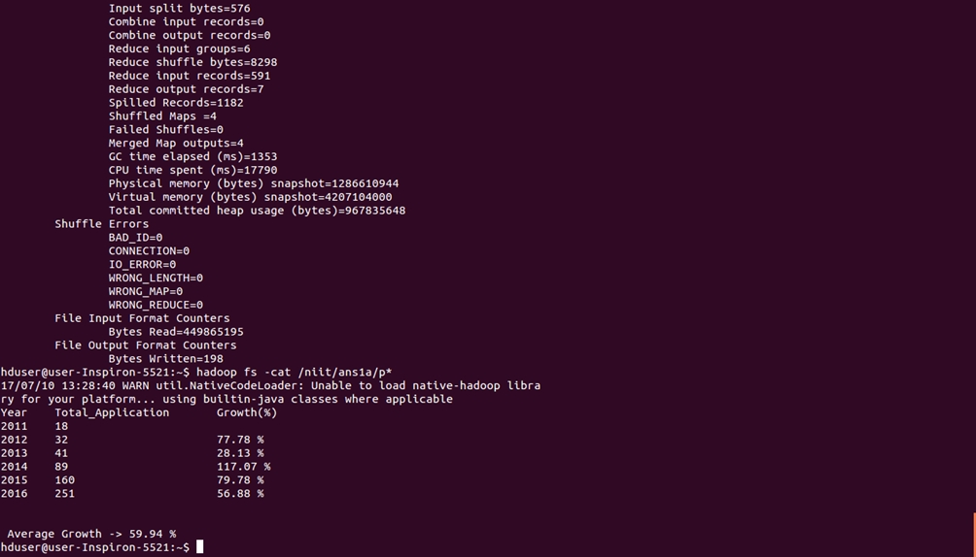

|  |  |  |  |
| --- | --- | --- | --- |
| Year | Total_Application | Growth(%) | DELTA Y/INCREASE |
| 2011 | 18 |  |  |
| 2012 | 32 | 78% | 14 |
| 2013 | 41 | 28% | 9 |
| 2014 | 89 | 117% | 48 |
| 2015 | 160 | 80% | 71 |
| 2016 | 251 | 57% | 91 |
|  |  |  |  |

The no of petitions is increasing over time but the max growth is in 2014 from previous year(2013)

b) **import java.io.IOException;  
import java.util.TreeMap;  
  
import org.apache.hadoop.conf.Configuration;  
import org.apache.hadoop.fs.*;  
import org.apache.hadoop.io.*;  
import org.apache.hadoop.mapreduce.lib.input.*;  
import org.apache.hadoop.mapreduce.lib.output.*;  
import org.apache.hadoop.mapreduce.*;  
public class ques1b {  
    public static class myMapper extends Mapper<LongWritable, Text, Text, IntWritable>  
    {  
        public void map(LongWritable key, Text value,Context context) throws IOException, InterruptedException  
        {  
            String[] arr = value.toString().split("\t");  
            int year =  Integer.parseInt(arr[7]);  
            context.write(new Text(arr[4]), new IntWritable(year));  
        }  
    }  
     
    public static class myReducer extends Reducer<Text, IntWritable, NullWritable, Text>  
    {  
        TreeMap<Double, String> tmap = new TreeMap<Double, String>();  
         
        public void reduce(Text key, Iterable<IntWritable> value, Context context) throws IOException, InterruptedException  
        {  
            
            long year11 = 0, year12 = 0, year13 = 0, year14 = 0, year15 =0, year16 =0;  
            double cyc1 = 0.0, cyc2 = 0.0, cyc3 = 0.0, cyc4 = 0.0, cyc5 = 0.0, finavg = 0.0;  
            for (IntWritable val : value)  
            {  
                if(val.get() == 2011)  
                    year11++;  
                else if(val.get() == 2012)  
                    year12++;  
                else if(val.get() == 2013)  
                    year13++;  
                else if(val.get() == 2014)  
                    year14++;  
                else if(val.get() == 2015)  
                    year15++;  
                else if(val.get() == 2016)  
                    year16++;  
            }  
             
            cyc1  = (year11!=0 ? ((year12 - year11) * 100 /year11) : 0);  
            cyc2  = (year12!=0 ? ((year13 - year12) * 100 /year12) : 0);  
            cyc3  = (year13!=0 ? ((year14 - year13) * 100 /year13) : 0);  
            cyc4  = (year14!=0 ? ((year15 - year14) * 100 /year14) : 0);  
            cyc5  = (year15!=0 ? ((year16 - year15) * 100 /year15) : 0);  
             
            finavg = (cyc1 + cyc2 + cyc3 + cyc4 + cyc5)/5;  
            String temp = key + "\t" + "Cycle Growth -> ( " + cyc1 + "," + cyc2 + "," + cyc3 + "," + cyc4 + "," + cyc5 + ") \t" + "Average Growth -> " + finavg;  
            if((year11 + year12 + year13 + year14 + year15 + year16) > 1000)  
                tmap.put(finavg, temp);  
            /*This condition is to exclude records like below  
             * 2011    1,     2013    2, 2015    1, 2014    2, 2016    249,  
             * BUSINESS ANALYST 2    Cycle Growth -> ( -100.0,0.0,0.0,-50.0,24800.0) Average Growth -> 4930.0  
            */  
             
            if(tmap.size() > 5)  
                tmap.remove(tmap.firstKey());  
                 
        }  
         
        public void cleanup(Context context) throws IOException, InterruptedException  
        {  
            for( String m:tmap.descendingMap().values())  
            {  
                context.write(NullWritable.get(), new Text(m));  
            }  
        }  
    }  
     
    public static void main(String[] args) throws ClassNotFoundException, IOException, InterruptedException  
    {  
        Configuration conf = new Configuration();  
        Job job = Job.getInstance(conf);  
         
        job.setJarByClass(ques1b.class);  
        job.setMapperClass(myMapper.class);  
        job.setReducerClass(myReducer.class);  
                 
        job.setMapOutputKeyClass(Text.class);  
        job.setMapOutputValueClass(IntWritable.class);  
     
        job.setOutputKeyClass(NullWritable.class);  
        job.setOutputValueClass(Text.class);  
         
        FileInputFormat.addInputPath(job, new Path(args[0]));  
        FileOutputFormat.setOutputPath(job, new Path(args[1]));  
        System.exit(job.waitForCompletion(true)? 0: 1);  
         
    }  
  
  
}**

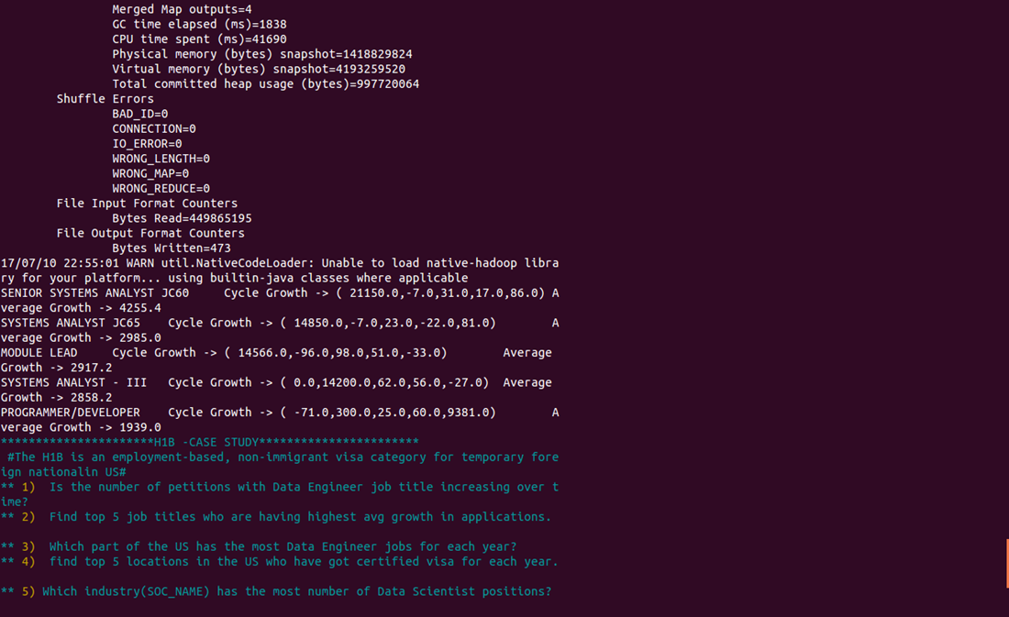

**Task2**

**7) Create a bar graph to depict the number of applications for each year**

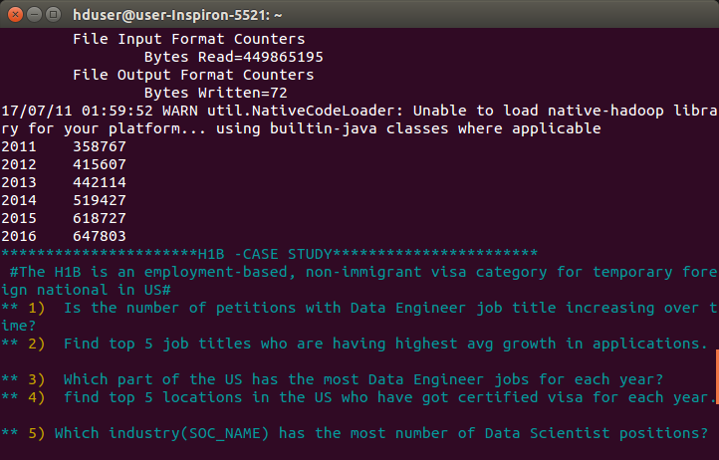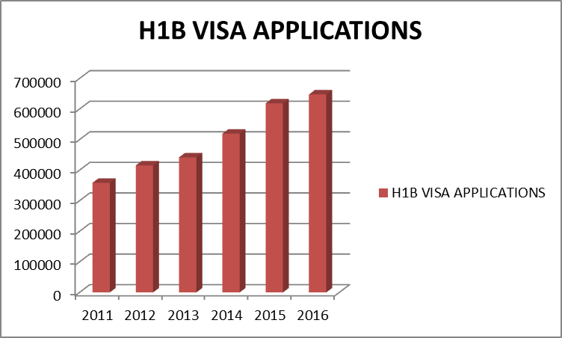

**Task 3**

**Which are the employers along with the number of petitions who have the success rate more than 70% in petitions. (total petitions filed more than 1000) ?**

**import org.apache.hadoop.io.Text;  
import org.apache.hadoop.io.LongWritable;  
import org.apache.hadoop.io.FloatWritable;  
import org.apache.hadoop.mapreduce.Job;  
import org.apache.hadoop.mapreduce.Mapper;  
import org.apache.hadoop.mapreduce.Reducer;  
import org.apache.hadoop.conf.*;  
import org.apache.hadoop.fs.*;  
import org.apache.hadoop.mapreduce.lib.input.*;  
import org.apache.hadoop.mapreduce.lib.output.*;  
  
  
  
import java.io.*;  
  
public class ans9 {  
      
    public static class h1bMapper1 extends Mapper<LongWritable,Text,Text,Text>  
    {  
        public void map(LongWritable key,Text value,Context context)throws IOException, InterruptedException  
        {  
            String[] abc = value.toString().split("\t");  
            context.write(new Text(abc[2]), value);  
              
              
              
              
        }  
    }  
    public static class h1breducer1 extends Reducer<Text,Text,Text,FloatWritable>  
    {  
        public void reduce(Text key,Iterable<Text> value,Context context)throws IOException, InterruptedException  
        {int count = 0,count1 = 0,count2 = 0;  
        float success;  
        long myval = 0 ;  
        for(Text t:value)  
        {  
            String parts[] = t.toString().split("\t");  
            count++;  
            if(parts[1].equals("CERTIFIED"))  
            {  
                count1++;  
            }  
            if(parts[1].equals("CERTIFIED-WITHDRAWN"))  
            {  
                count2++;  
            }  
        }  
      
          
        if(count > 1000)  
        {  
            success = ((count1+count2)*100)/count;  
            if(success > 70.0)  
            {  
            myval = (long) success;  
            }  
        context.write(key,new FloatWritable(myval));  
        }  
    }  
      
}  
    public static void main(String[] args) throws Exception{  
        Configuration conf = new Configuration();  
        //conf.set("name", "value");  
         
     Job job=Job.getInstance(conf,  "count");  
     job.setJarByClass(ans9.class);  
     job.setReducerClass(h1breducer1.class);  
     job.setMapperClass(h1bMapper1.class);  
     job.setMapOutputKeyClass(Text.class);  
     job.setMapOutputValueClass(Text.class);  
     job.setOutputKeyClass(Text.class);  
     job.setOutputValueClass(FloatWritable.class);  
     FileInputFormat.addInputPath(job, new Path(args[0]));  
     FileOutputFormat.setOutputPath(job,new Path(args[1]));  
     System.exit(job.waitForCompletion(true) ? 0 : 1);  
       
    }  
  
}**

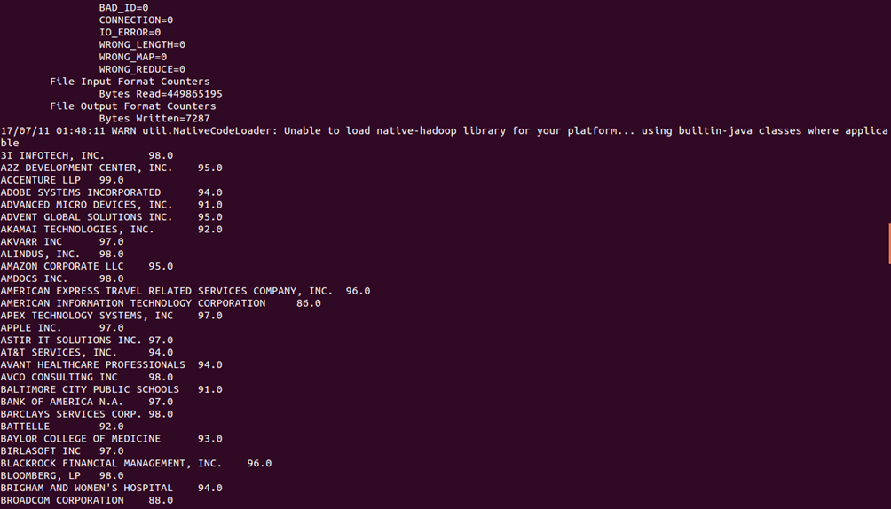

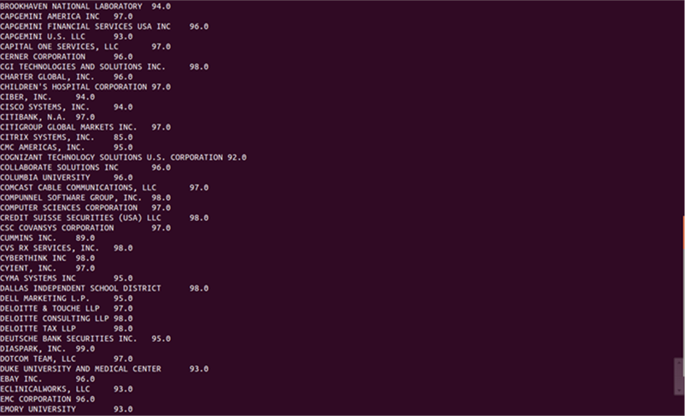



**Task4 SUCCESS RATE =(CERTIFIED +CERTIFIED-WITHDRWAN)/TOTAL *100**

**10) Which are the job positions along with the number of petitions which have the success rate more than 70% in petitions (total petitions filed more than 1000)?**

**import org.apache.hadoop.io.Text;  
import org.apache.hadoop.io.LongWritable;  
import org.apache.hadoop.io.FloatWritable;  
import org.apache.hadoop.mapreduce.Job;  
import org.apache.hadoop.mapreduce.Mapper;  
import org.apache.hadoop.mapreduce.Reducer;  
import org.apache.hadoop.conf.*;  
import org.apache.hadoop.fs.*;  
import org.apache.hadoop.mapreduce.lib.input.*;  
import org.apache.hadoop.mapreduce.lib.output.*;  
  
  
  
import java.io.*;  
  
public class ans10 {  
      
    public static class h1bMapper1 extends Mapper<LongWritable,Text,Text,Text>  
    {  
        public void map(LongWritable key,Text value,Context context)throws IOException, InterruptedException  
        {  
            String[] abc = value.toString().split("\t");  
            context.write(new Text(abc[4]), value);  
              
              
              
              
        }  
    }  
    public static class h1breducer1 extends Reducer<Text,Text,Text,FloatWritable>  
    {  
        public void reduce(Text key,Iterable<Text> value,Context context)throws IOException, InterruptedException  
        {int count = 0,count1 = 0,count2 = 0;  
        float success;  
        long myval = 0 ;  
        for(Text t:value)  
        {  
            String parts[] = t.toString().split("\t");  
            count++;  
            if(parts[1].equals("CERTIFIED"))  
            {  
                count1++;  
            }  
            if(parts[1].equals("CERTIFIED-WITHDRAWN"))  
            {  
                count2++;  
            }  
        }  
      
          
        if(count > 1000)  
        {  
            success = ((count1+count2)*100)/count;  
            if(success > 70.0)  
            {  
            myval = (long) success;  
            }  
        context.write(key,new FloatWritable(myval));  
        }  
    }  
      
}  
    public static void main(String[] args) throws Exception{  
        Configuration conf = new Configuration();  
        //conf.set("name", "value");  
         
     Job job=Job.getInstance(conf,  "count");  
     job.setJarByClass(ans10.class);  
     job.setReducerClass(h1breducer1.class);  
     job.setMapperClass(h1bMapper1.class);  
     job.setMapOutputKeyClass(Text.class);  
     job.setMapOutputValueClass(Text.class);  
     job.setOutputKeyClass(Text.class);  
     job.setOutputValueClass(FloatWritable.class);  
     FileInputFormat.addInputPath(job, new Path(args[0]));  
     FileOutputFormat.setOutputPath(job,new Path(args[1]));  
     System.exit(job.waitForCompletion(true) ? 0 : 1);  
       
    }  
  
}**

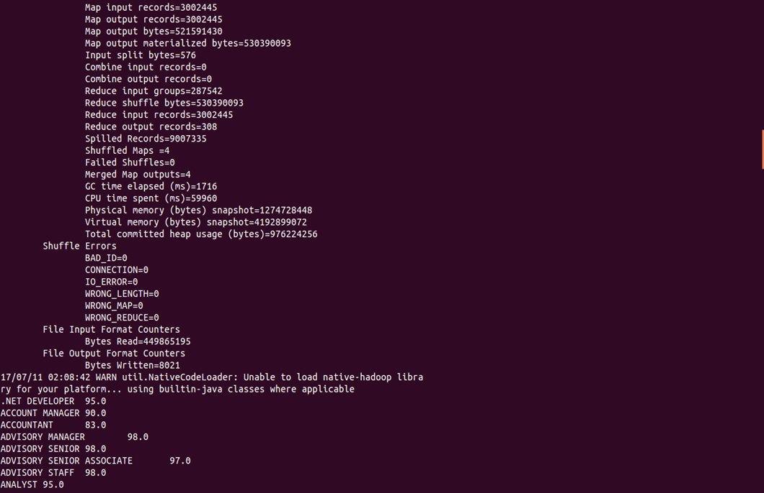

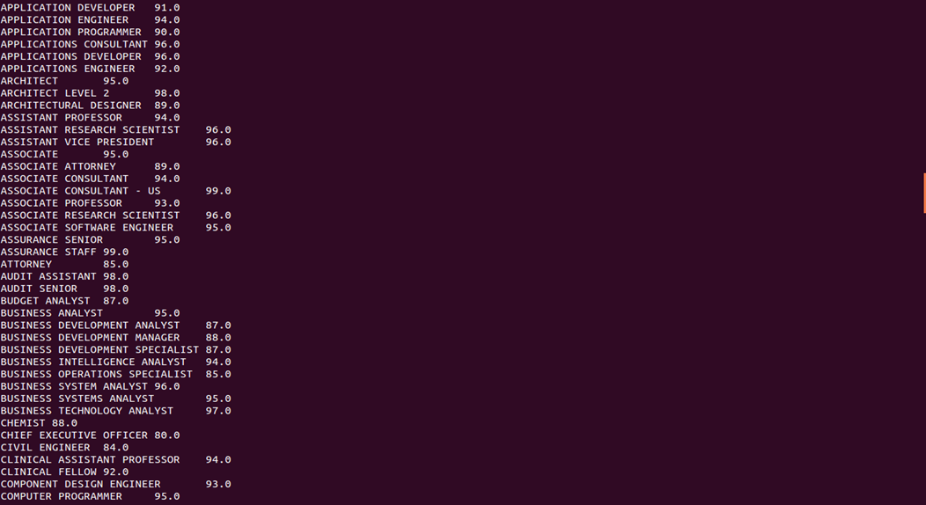

**APACHE SQOOP**

Apache Sqoop(TM) is a tool designed for efficiently transferring bulk data between [Apache Hadoop](http://hadoop.apache.org/) and structured datastores such as relational databases.

**TASK1**

**11) Export result for question no 10 to MySql database.**

**sqoop export --connect jdbc:mysql://localhost/employee --username root --password '1234' --table exportAns10 --update-mode allowinsert --update-key employee_id --export-dir /niit/employee.txt --input-fields-terminated-by '\t' ;**

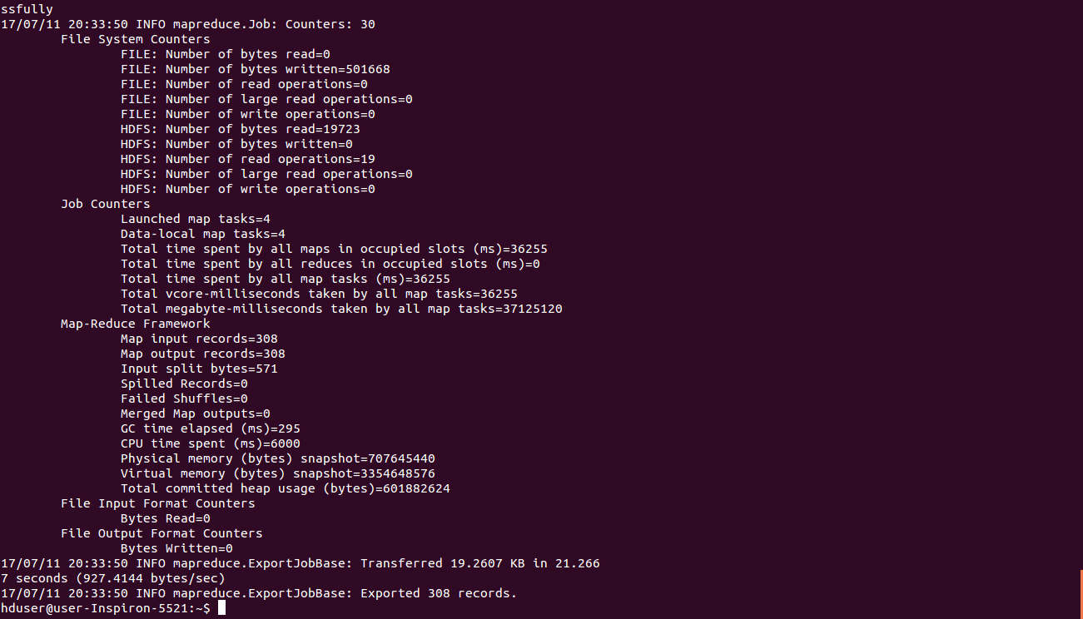

# CONCLUSIONS:

Following is the conclusion that we can draw based on the tasks performed by us:

* As the census data is given in csv format, by using Hive all punctuations are removed and we trimmed three case_status to ‘DENIED’
* For group by, join and filter based data retrieval Pig is very efficient.
* MapReduce code written in Java makes the complex analysis quite easy.
* From the census data and after running all the tasks we can conclude that

**1**)

2011    358767  
2013    442114  
2015    618727  
2012    415607  
2014    519427  
2016    647803

2) The no of certified visa applications filed are more compared to non-certified, withdrawn and denied

3) Statistians (SOC_name) has the most number of Data Scientist positions.

4)Though MapReduce code written in Java makes the complex analysis quite easy, Hive and Pig are easier to retrieve data efficiently and lines of code is also very less compared to MapReduce programs.

5)The no of petitions is increasing over time but the max Increase(%) is in 2014 from previous year(2013).